1. **First Web Api using .Net core**

ValuesController.cs

using Microsoft.AspNetCore.Mvc;

using System.Collections.Generic;

namespace FirstWebApi.Controllers

{

[ApiController]

[Route("api/[controller]")]

public class ValuesController : ControllerBase

{

private static List<string> values = new List<string> { "value1", "value2" };

// GET: api/values

[HttpGet]

public ActionResult<IEnumerable<string>> Get()

{

return Ok(values);

}

// GET: api/values/1

[HttpGet("{id}")]

public ActionResult<string> Get(int id)

{

if (id < 0 || id >= values.Count)

return NotFound("Value not found");

return Ok(values[id]);

}

// POST: api/values

[HttpPost]

public IActionResult Post([FromBody] string value)

{

values.Add(value);

return Ok(new { message = "Value added", values });

}

// PUT: api/values/1

[HttpPut("{id}")]

public IActionResult Put(int id, [FromBody] string newValue)

{

if (id < 0 || id >= values.Count)

return NotFound("Value not found");

values[id] = newValue;

return Ok(new { message = "Value updated", values });

}

// DELETE: api/values/1

[HttpDelete("{id}")]

public IActionResult Delete(int id)

{

if (id < 0 || id >= values.Count)

return NotFound("Value not found");

values.RemoveAt(id);

return Ok(new { message = "Value deleted", values });

}

} }

Working

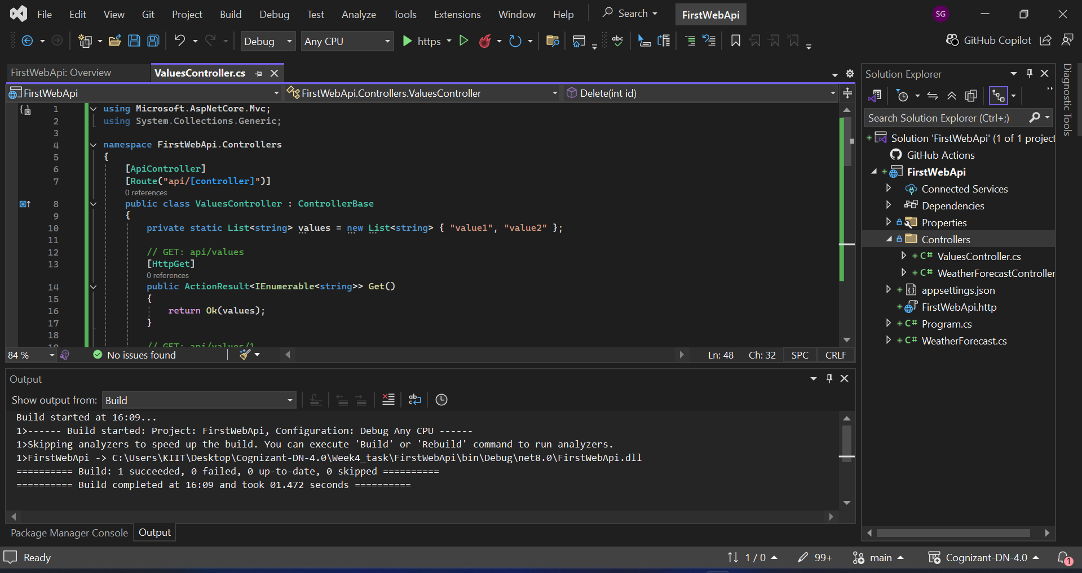

1. GET

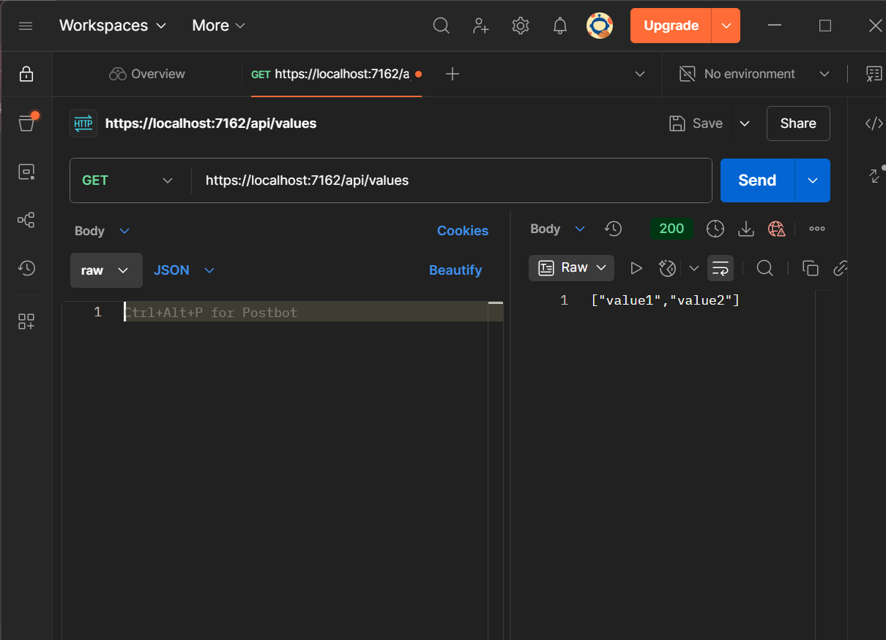

1. POST

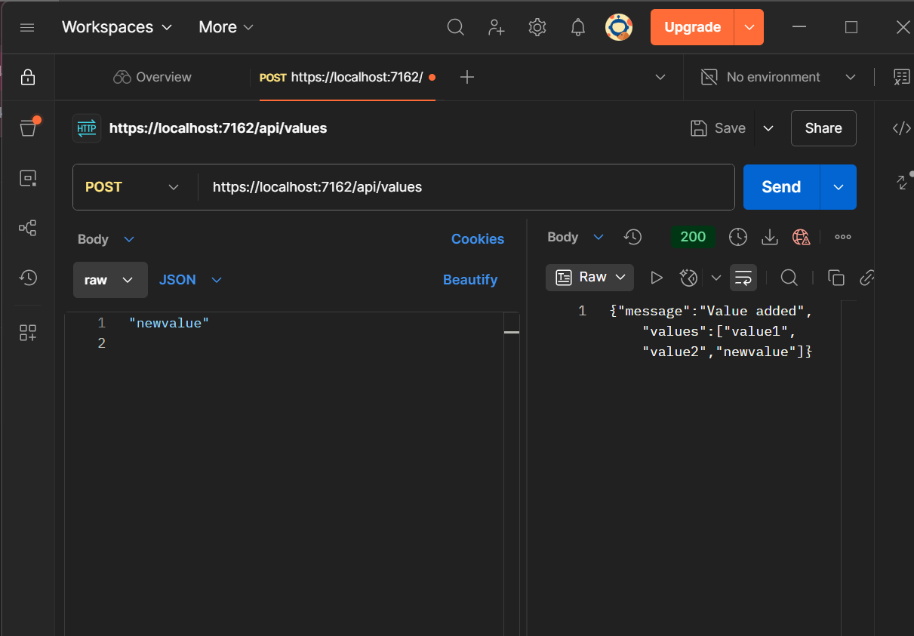

1. PUT

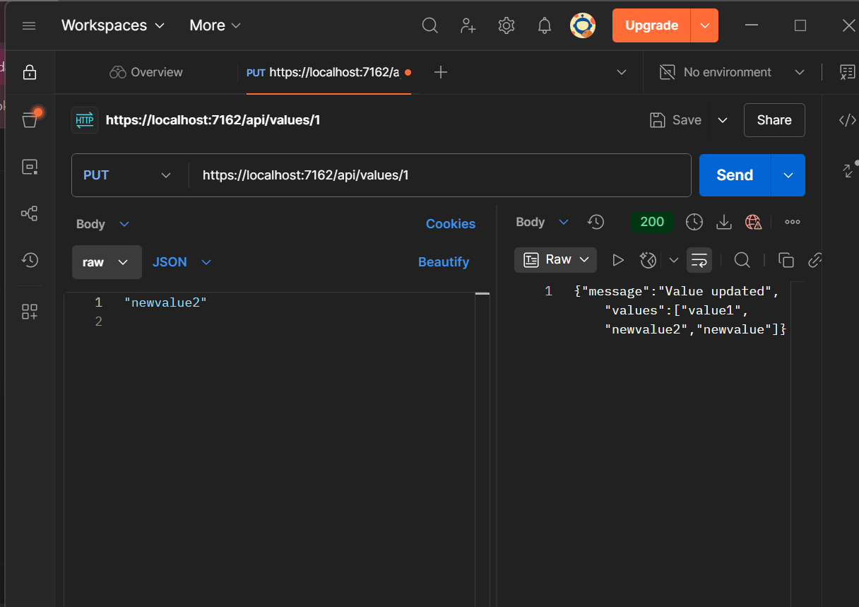

1. DELETE

